Home page Correction plans
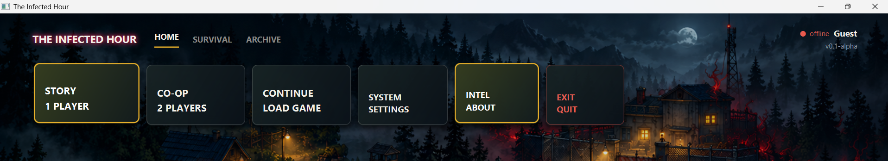
In this part will add another block about COLLECTION

This Page need to be modified , Mainly the design. UI image need to be polished,

Here this 2 character need to be change outfit based on our character

Collection

- Name / Title: Elric — Field Striker
- Role: Melee Combat & Containment
- Bio:
"A resilient survivor who thrives under pressure. Built for close-quarters clearing and holding choke points against infected swarms."
- Playstyle & Perks:
  - Combat Focus: +20% Melee attack speed and knockback.
  - Hazard Resistance: 30% slower contamination meter buildup in toxic zones.

Name / Title: Jane — Tactical Scout
- Role: High Agility & Objective Runner
- Bio:
"Analytical and razor-sharp. Uses superior agility and tactical blade strikes to secure quarantine zones and rescue survivors before time runs out."
- Playstyle & Perks:
  - Agility Focus: +15% base movement speed and fast dash recovery.
  - Field Expertise: 35% faster sanitation node and objective interactions.
  - Starting Gear: Tactical Side Blade & Bio-Sample Scanner.

Level 1 correction
1.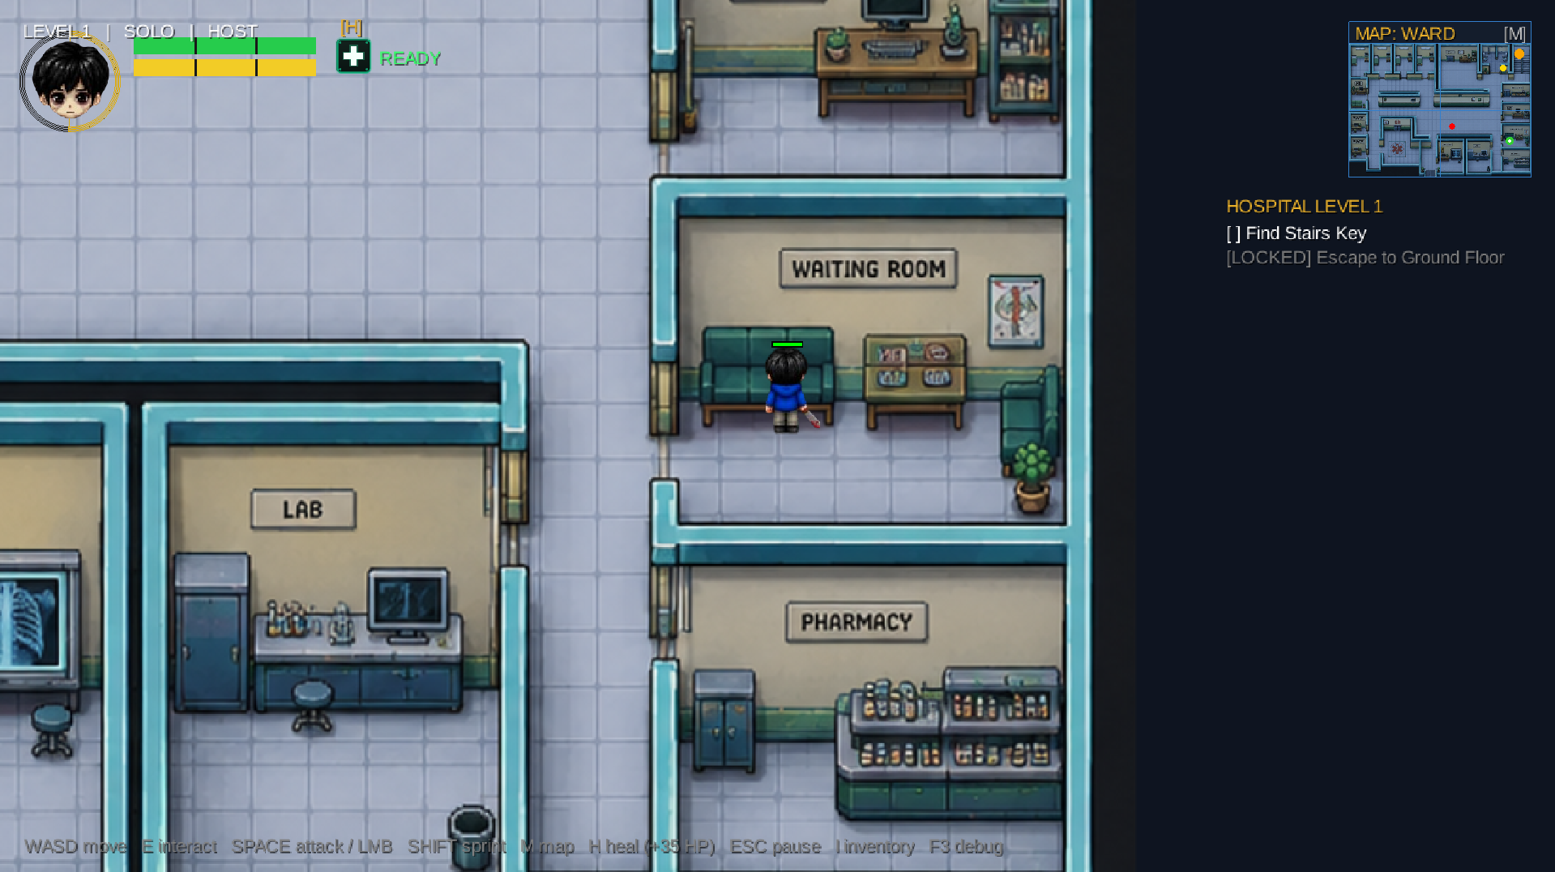
In this room Zane will stay Locked or senseless, We need to find revive kit to revive her.
2. When press O- will show objective
3.
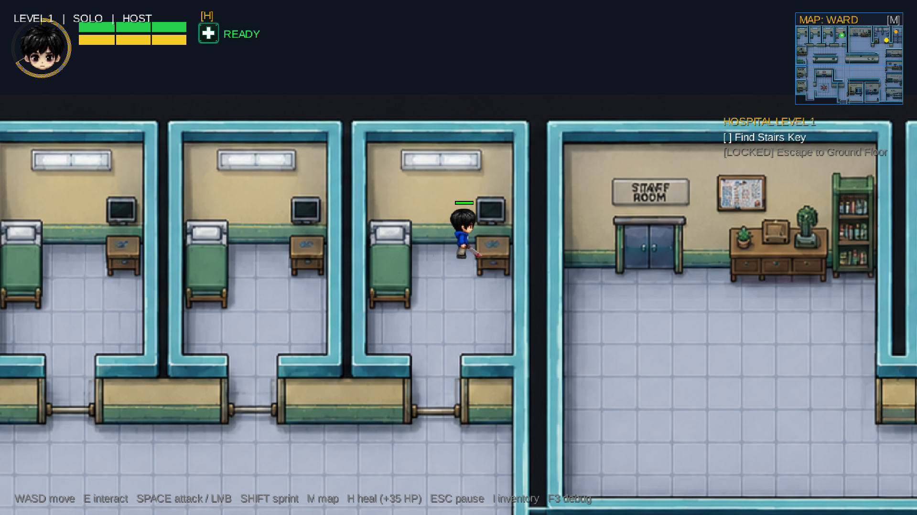there will be 1 part of revive kit and a medkit
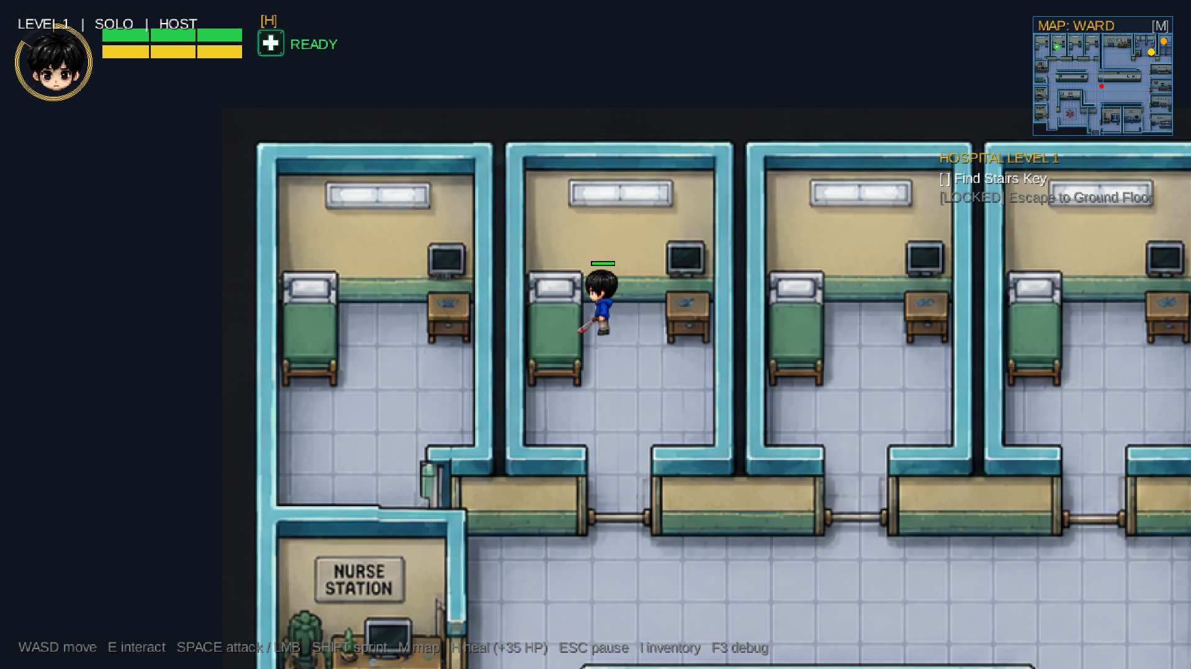
There will be another part
4.
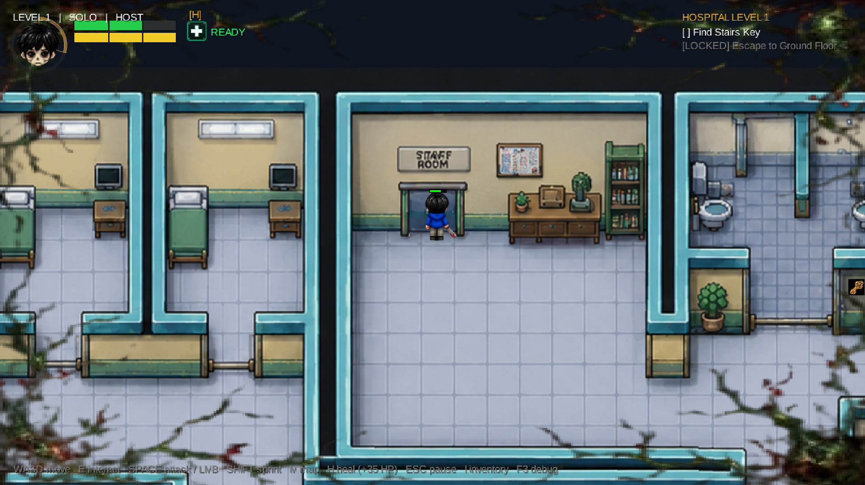 there will be 2 villlegers and they will follow Jane, we need to protect them from Zombie bites. And Jane will produce 1 medcit in 60 seconds. She can choose whom to heal, Villager 1 or villager 2 or Jane. Jane heal ability is 50.
Elric heal ability is 35.
5.
Jane will also get a katana and she will also knock zombies.
Her damage will be 30 per hit and Elric damage will be 50 per hit.
6.
Defeating 1 zombie will get 1 coin, Reviving jane will give 3 coin, If we able to finish level 1 with 2 villagers; will ger 10 coin. Per villager will get 5 coin.

7.

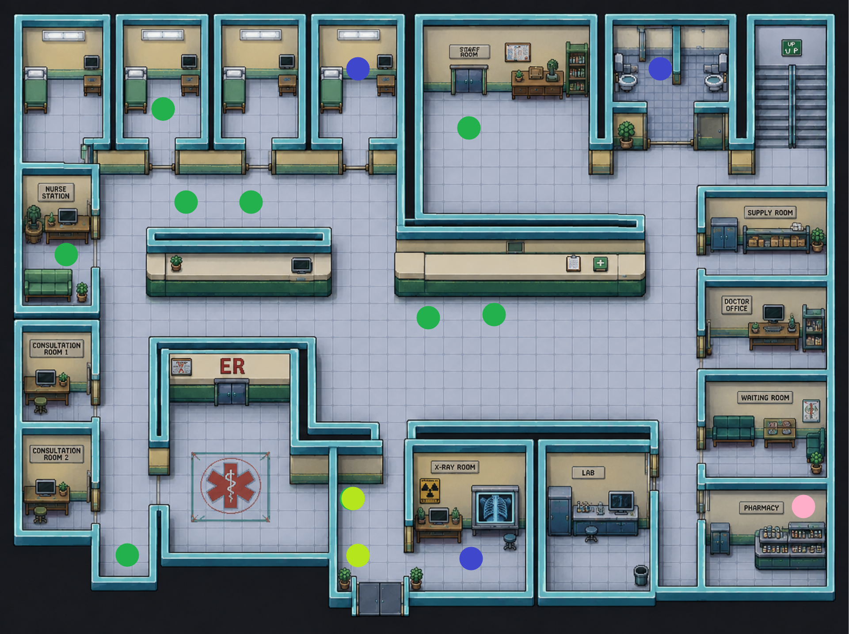
The Green Dot are Location of the Zombies(active).
Pink Dot is location of senseless Jane
Blue Dot are locations of our villagers.
Yellow is also Zombie(sleeping) When we will take villager 1 with us, the sleeping Zombies will be active.
Jane task is to find the villagers and interact with them.

8.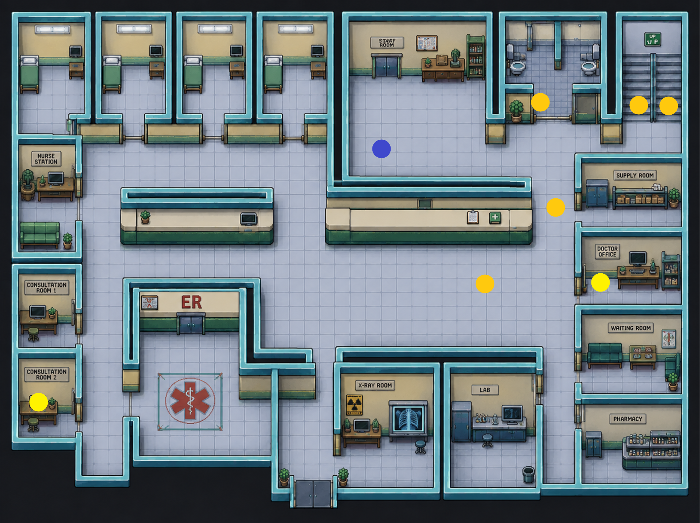
Yellow are the location of Revive kit or herve parts. 2 broken part will construct mixed herb and with that will revive jane.
Blue is Location of the key.
When will Take key in the Gold colour dots there will appear Zombies(active) and new objective will be to kill all zombies and need to beat them all to Finish Objective.

Then will appear Another objective in Red color will need to defeat the boss Zombie.
And by defeating this will clear Level 1.

Level 2 correction
Will describe when Sadnan will provide map

Level 3 correction
Need to discuss with Sadnan

Story
Elric an Agent of Oscorp Organization, It’s a private organization.
Arrived in this village.
Oscorp got message that From their lab a Bio weaponized virus was stolen from One of their employee.
If fail to contaminate it, need to destroy the core or the whole population will become zombie.

In level 1 Elric will rescue Jane and some villagers. Jane is Undercover Agent of Government.
In level 2 he will rescue another injured agent and 3 villagers.
In level 3 when we will beat the final boss, he will get a key and an antidote.
With this he will unlock a room and will find his Best friend(which will be a girl character) who came here 2 months ago for taking medical data for research and got missing.
Then Elric need to take decision
- 1.With the antidote he will save his best friend
- 2.Or he will sacrifice his best friend and give the antidote to Oscorp Organization to save humanity.
If He choose 1 There will be not fight and will show the story that his best friend died.
If He choose 2 , He will fight will Jane. This time Jane will do 60 damage per hit and Elric will do 50 damage per hit and if possible we will implement Parry and dodge while fighting.

